Mobeen’s oracle database notes:

Give these a read and tell me what you think.

Read section 11 – MUST to understand how to query sql database

Primary key (PK): a primary key is a column or set of columns that uniquely identifies each row in a table. Each table has a PK and must be unique

Candidate key: a column which is unique and can also be selected as a PK for a table. Basically another PK but you didn’t select it but meets the conditions of a PK, can select if you want.

Alternate or unique key (UK): what the candidate key turns into if you didn’t select it as PK

Foreign key (FK): is reference to a PK in the same table or another table

Section 11 slide 2 contains example database table for us to use.

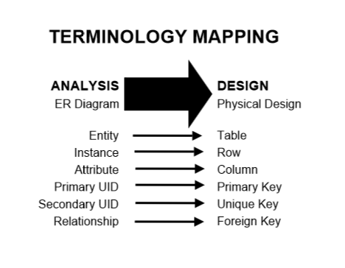

Table diagrams notations:

First row of every table should be table name (entity name)

Column should contain relevant name and key type

All mandatory (\*) and optional (o) attributes must be stated in the column if applicable like the entity relationship diagram.

Columns should make names plurals

No spaces use underscores or other relevant abbreviations.

How to name a table, short names.

